Exploratory data analysis using R
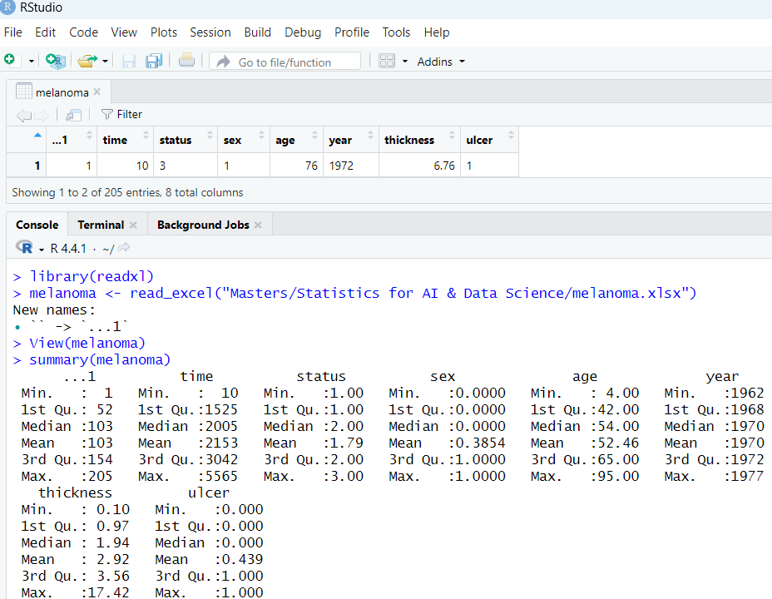

The above screen shot shows the code summary for all descriptive statistics for all the available measurements. However, the categorical variables are taken as continuous hence the next screenshot shows code to fix this.
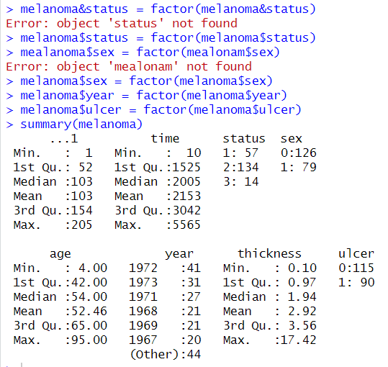

The second screenshot also shows the mean for each of the continuous variables, with a mean survival time of 2,153 days (about 5.9 years) which indicates that, on average, patients in this study lived for around six years after their surgery. The second measurement is the mean age, which is 52.46, implies that melanoma surgeries in this dataset were more commonly performed on middle-aged adults, which aligns with the known age range where melanoma risk increases due to cumulative sun exposure and other factors. (need a source) . The final continuous variable is the thickness with a mean of 2.92, suggests that, on average, these melanomas were relatively thick. In melanoma prognostics, tumors thicker than 1 mm are often associated with higher risks of metastasis and poorer outcomes, with risks increasing as thickness rises.(need a source). This average thickness could indicate a study population with a relatively serious melanoma diagnosis.

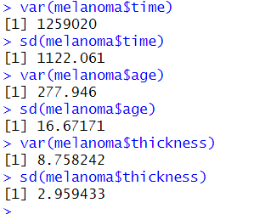
The above screenshot shows a standard deviation of over 1,000 days (about 3 years) indicates that survival times vary greatly around the mean of 2,153 days. This spread suggests that, while some patients survived for only a short time, others lived for several years after their surgery. A standard deviation of around 16.67 years suggests a moderate spread of ages around the mean age of 52.46. This means that while most patients were around middle age, there was a reasonable diversity in age, including both younger and older patients. A standard deviation of nearly 3 mm, compared to the mean thickness of 2.92 mm, suggests a large spread around the average. This means that the dataset includes a mix of both very thin and quite thick tumors, rather than thickness values clustering closely around the mean. This wide range might imply different stages or severities of melanoma within the patient population.

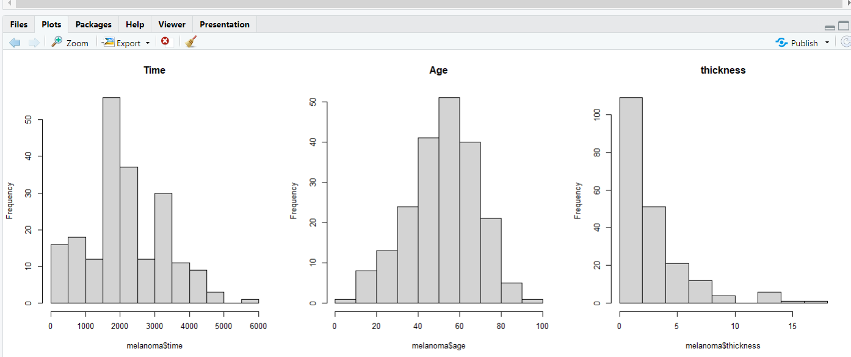
The next screenshot shows histograms of the three continuous variables the time, age and the Thickness. The time histogram follows a normal distribution but inaccurately as multiple values away from the mean have higher frequencies than the ones close to the mean. The age histogram shows an accurate normal distribution which connects well to the standard deviation as a lot of the values are spread relatively close to the mean. In addition, the thickness Histogram does not show a normal distribution. The mean value is located all the way to the left of the graph and the rest of the values’ frequencies reduce the further you go to the right of the X axis.

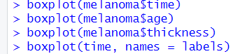
The next screenshot shows code for generating box plots for the time, age and thickness.

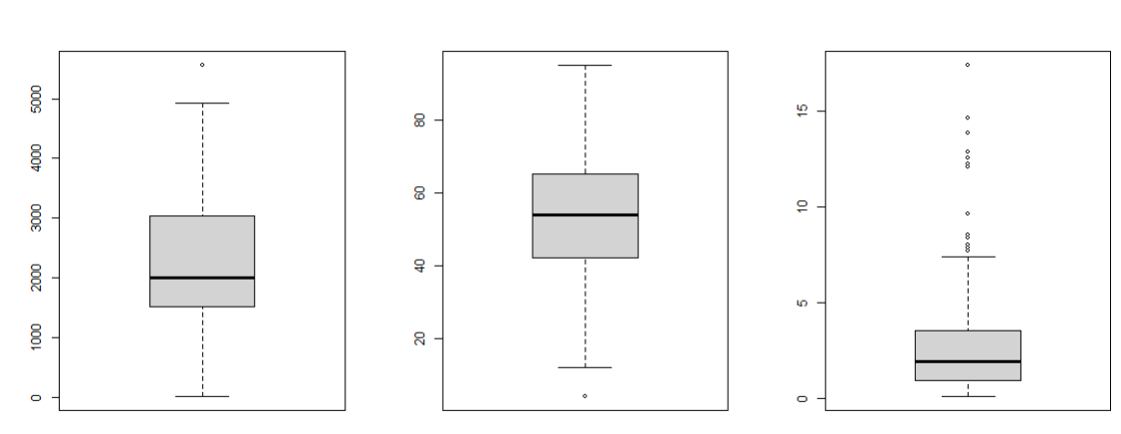
The next screenshot shows the three generated boxplots with the time (Left), age(middle) and thickness(right). There’s one outlier for the time, one outlier for the age and multiple outliers for the thickness.

The blue graph shows count 2 has the largest count(134) indicating many patients stayed alive, count 1 is the second largest showing many died from melanoma and count 3 is the smallest
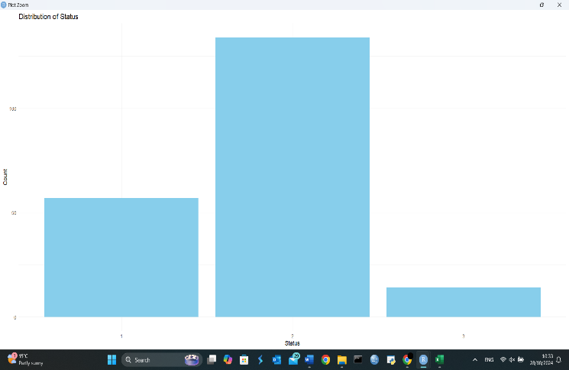
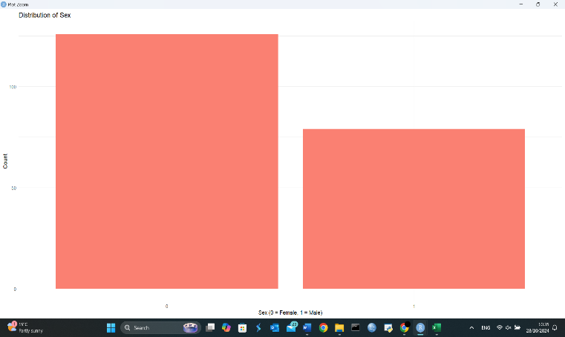

The red graph shows Females (0) have the largest count 126 whereas the males are just above 75. The green graph shows Ulceration (0) has the most count 115, whereas (1) has the least count at 90.
The yellow graph shows year 1972 has the most count at over 40. Years 1962, 1964, 1974 and 1977 all have counts less than 5.
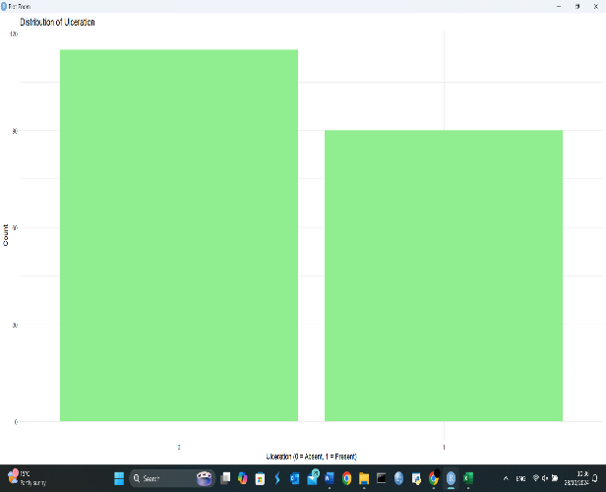
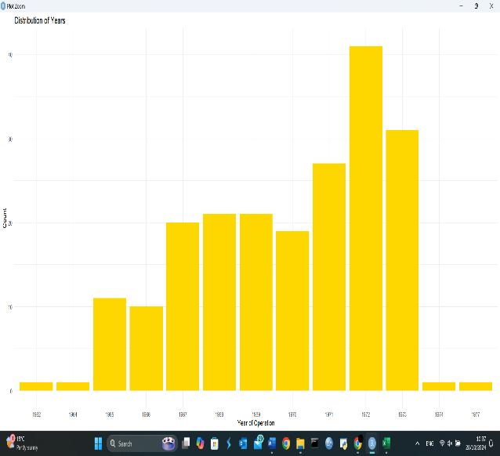

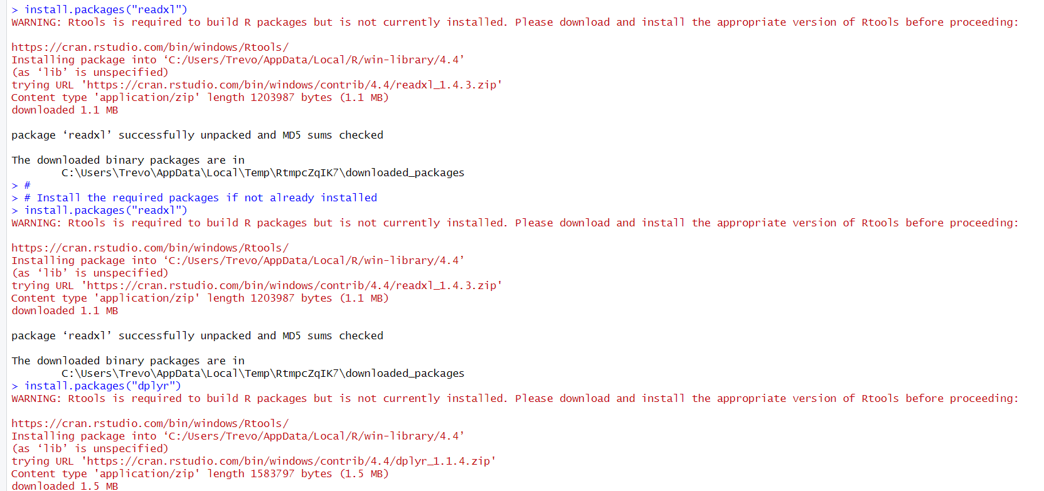
The next two screenshots show code for regression analysis and appropriate correlation computations for the relationship between time, thickness and age as required.

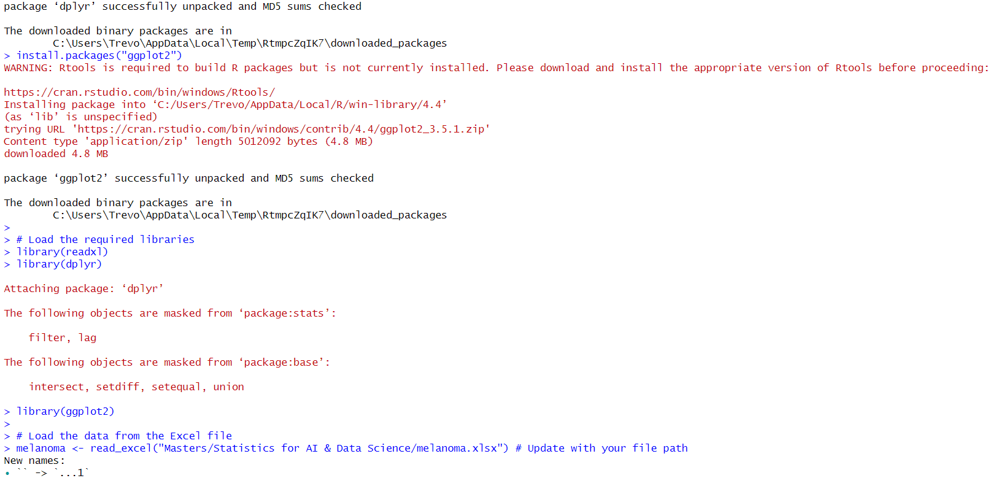
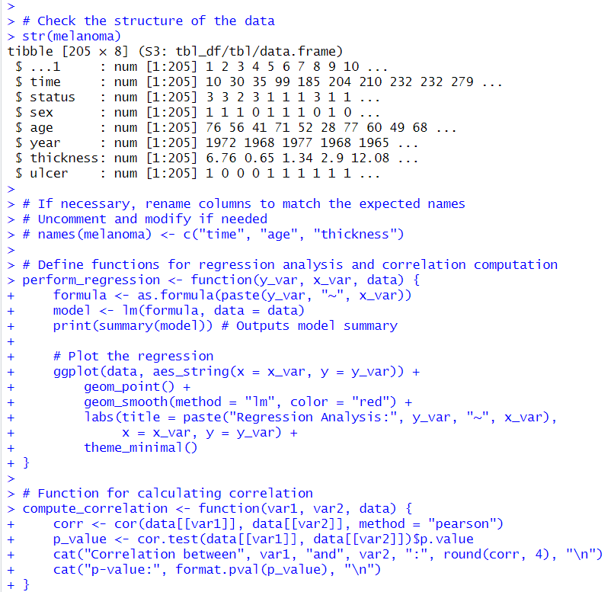

The screenshot above shows a correlation Coefficient value of -0.2354 this shows a moderate correlation between survival time and age. As age increases, survival time tends to decrease, but the relationship is not very strong. A P-value of 0.00067928, it means that the correlation is statistically significant (p < 0.001). So we reject the null hypothesis, hence, we conclude that tumor thickness is a significant predictor of survival time.

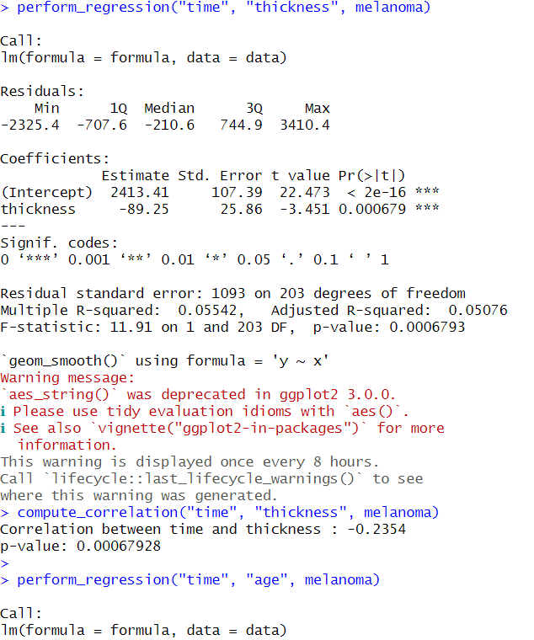

The t-value for the age coefficient is -0.3015, which indicates that this coefficient is significantly different from zero. The p-value (1.1161e-05) is much lower than 0.001, hence we reject the null hypothesis. Hence, age is a significant predictor of survival time. This code was repeated for the other required variables.

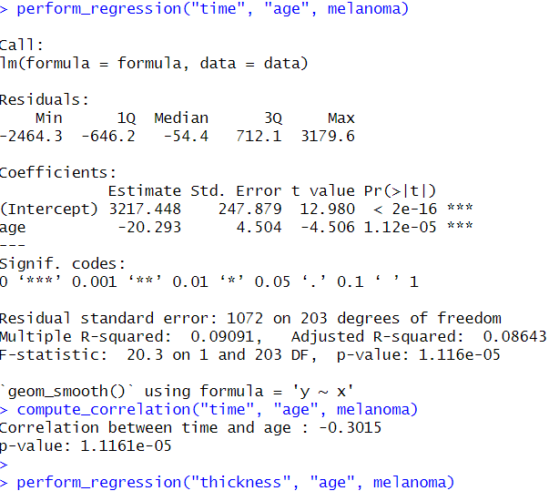

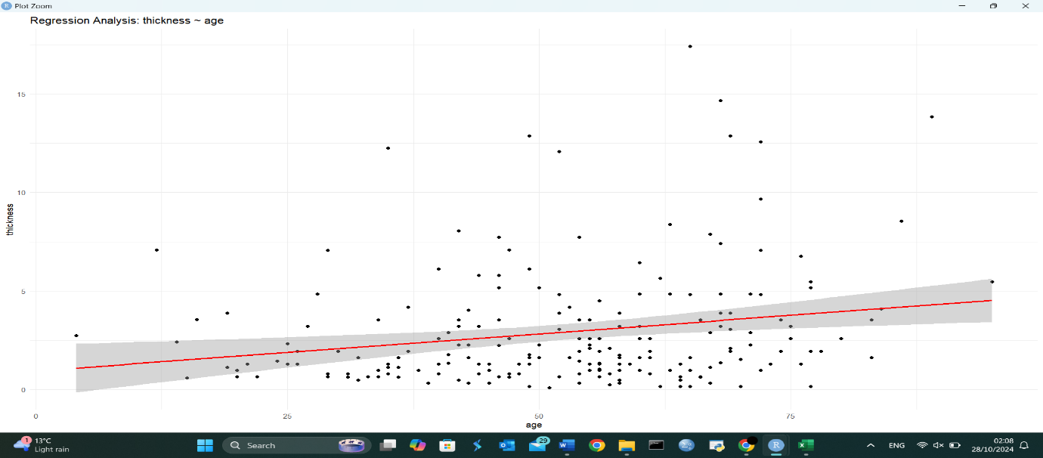
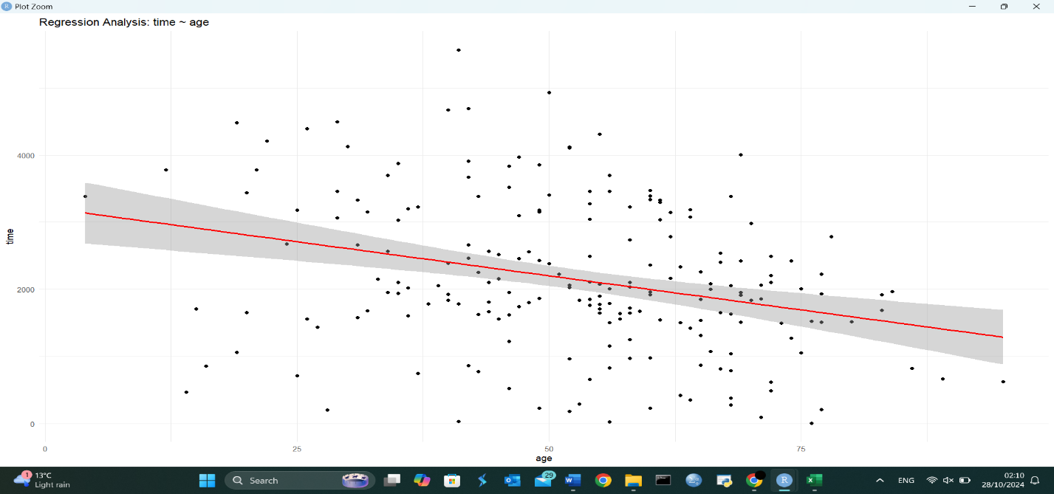
Graph for time and age shows a negative correlation. The older patients get the lower the survival time.
Graph for thickness and age shows a moderate positive correlation. The older the patients grows the thicker the tumour increases.

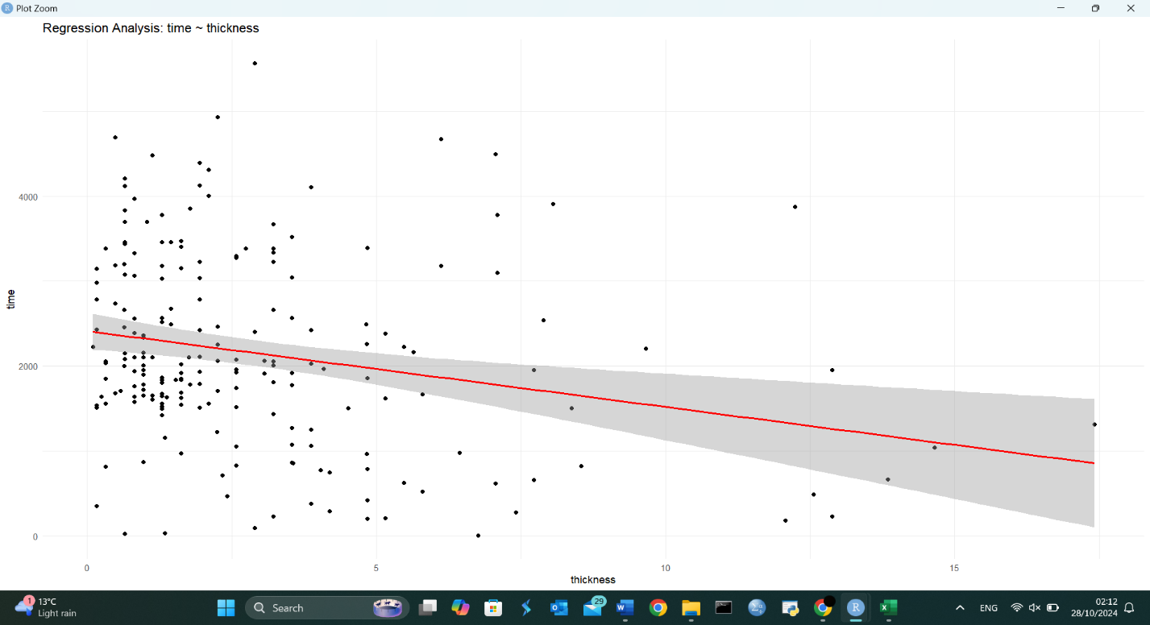
The screenshot below shows a negative linear regression model.

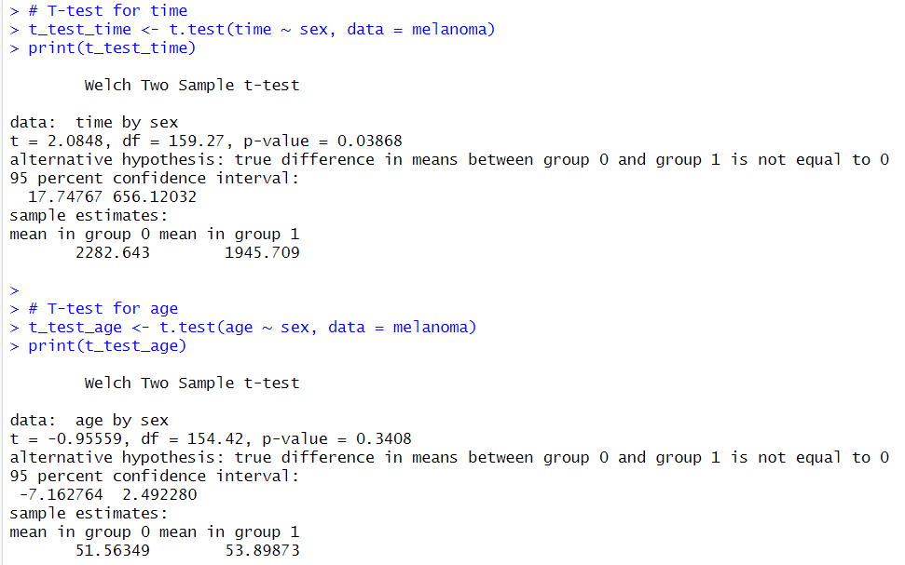
The code above shows a welch two sample t-test used, which is valid to use.
The p-value (0.03868) is less than 0.05, hence we reject the null hypothesis. This suggests that there is a statistically significant difference in mean survival times between males(group1) and female(groip0) patients. The t-test results suggest that there is a statistically significant difference in survival times between male and female patients with melanoma. Mainly, males tend to have shorter survival times than females in this dataset.
First screenshot shows on average female patients have longer survival times than male patients by approximately 336.934 days (2282.643 – 1945.709)

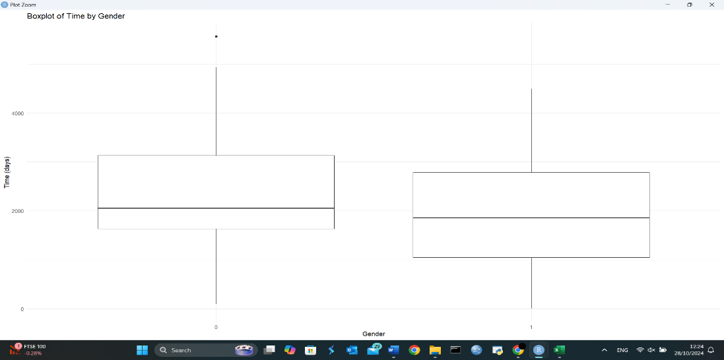

Box plot shows that on average women experience longer survival time than men.
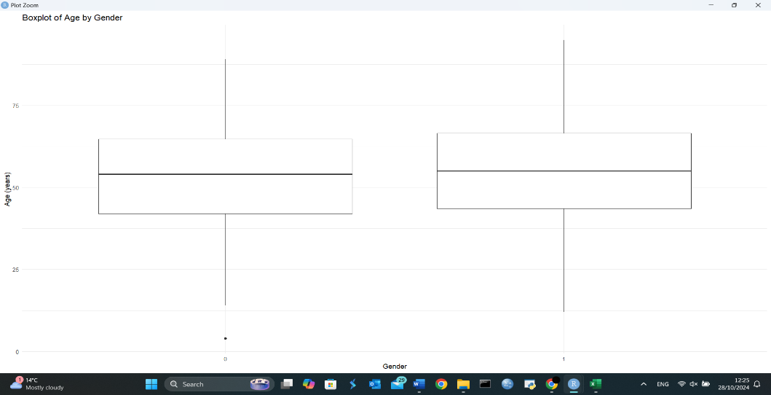
The box plot shows that on average in this study men were older than the women.

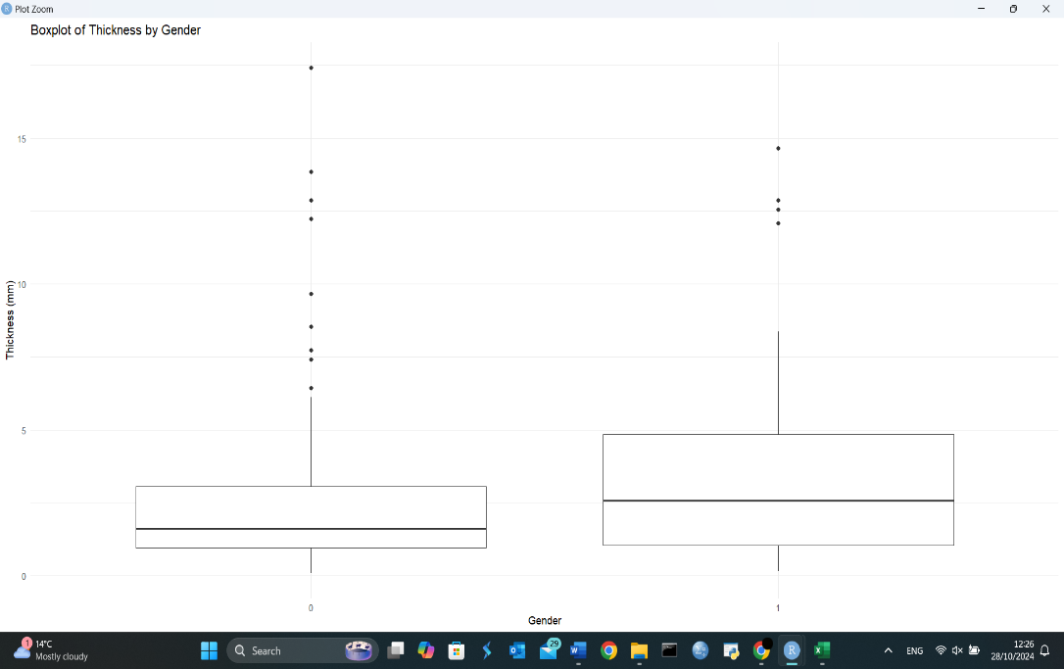
The boxplot shows that on average the men had thicker tumours than the women.

Conclusion
The T-test for age based on sex indicate a p-value of 0.3408 which is greater than 0.05, suggesting we do not have enough evidence to reject the null hypothesis. Indicating that there is no statistically significant difference in mean age between male and female patients in the dataset. The T-test shows a p-value of 0.01009 less than 0.005 so we reject the null hypothesis, suggesting that there is a significant difference in tumour thickness based on sex, with male patients showing a greater mean tumour thickness than female patients in the dataset. Furthermore, the regression analysis of the thickness and age shows a p value of 0.0022234, meaning that the correlation is statistically significant. Age is a significant predictor of tumour thickness, with each additional year of age relating with an increase of approximately 0.03772mm in thickness.
Recommendations
We could gather more data to increase the sample size, a larger sample cam improves the robustness of the statistical analyses. Addition and identification of more potential variables that could affect tumour thickness e.g. location of the tumour, Patient’s overall health, 2nd or 3rd diagnosis, diet, etc. We could use multivariate regression techniques to adjust for these variables. Maintain that all measurements of tumour thickness and other variables are taken using standardized protocols, this reduces measurement error, train personnel on consistent techniques for measuring data and recording data. Work with other researchers or seek peer review of the methodology and findings, external feedback can provide new information and highlight potential weakness in the approach.

